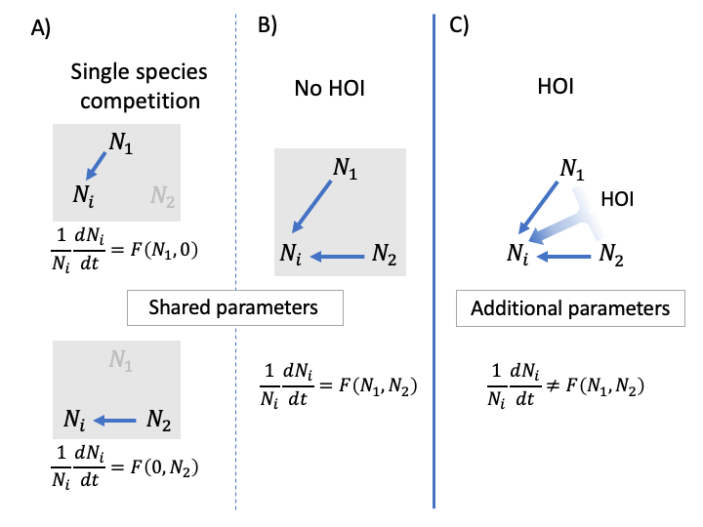

Figure 1. Conceptual definition of HOIs. In A, the competitive effects (blue arrows) of species 1 and 2 on the focal species are observed separately. The per capita growth rate of the focal species, *i,* is modeled as a function, *F*, of the density of competitor species 1 and 2. Importantly, *F* is fully specified by observing the effects of each species separately. In the communities in B and C, two competitor species are present together (i.e. *N*1 > 0 & *N*2 > 0). In B, the function *F* characterizes multispecies dynamics and there are no HOIs. In C, the function *F* does not characterize the multispecies case; specifically, additional parameters are required to model the HOI or IM that arises when competitor species one and two are present together.